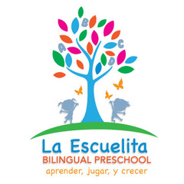 ACQUAINTANCE FORM
So that teachers might best serve your child, please provide us with this confidential information:

CHILD’S NAME______________________________________ DOB ______________
FAMILY INFORMATION:
Please give the names and ages of other children in the family and if they live in the home:

Please give the names and relationships of adults other than parents living in the home:

Do you have a caregiver or alternate childcare?

Who are other important people in your child’s life?

Do you have any pets?

Are there any changes or new situations we should be aware of (new baby, moving, divorce, death, etc.)?

What are the occupations of the parents?

Please turn over!

YOUR CHILD:
What is your child’s favorite story and song?

Does your child have any allergies?

What fears does your child have?

Are you aware of any problems your child has with speech, hearing, vision, or muscle control? Please tell us if you child receives any therapies.

How many hours of sleep does your child get on an average night?

Briefly outline your child’s typical day.

What activities does your child enjoy?

Has your child attended another preschool or child care center? Where? What schedule?

Is there anything else you would like to share with your child’s teacher?

Do you have any special talents or interests to share with our school?

